|  |
| --- |
| **Exercise 3** |

**Copy this file and open it in Word or some other editor where you can insert images. Be sure to read "How to Copy the Results of a Query" found in Module 2 in Canvas.    This is how you will be answering the following questions.**

Using the Premier Products database:

1. List the customer number, customer name, and sales rep that have the same rep number as customer number 282. This will need to be a subquery and do not test for sales rep 35 explicitly. Let MySQL do the work for you. Insert your query and results here.

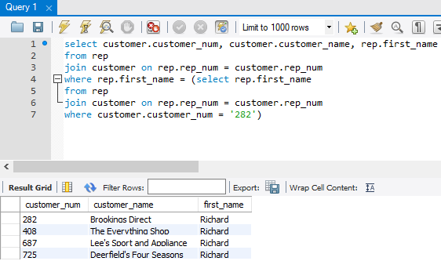

1. For each order, list the order number, order date, customer number, and customer name. Insert your query and results here.

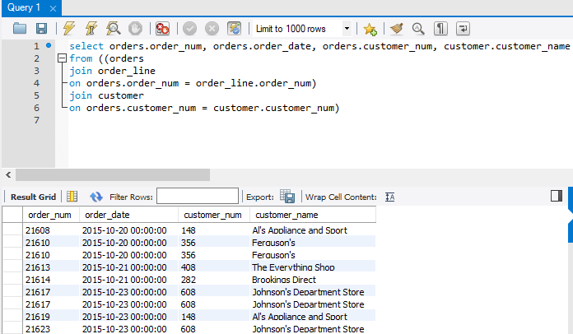

1. For each order placed on October 20, 2015, list the order_number, customer number, and customer name. Insert your query and results here.

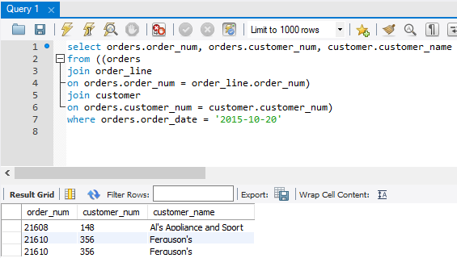

1. For each order placed on October 20, 2015, list the order number, part number, part description, and item class for each part ordered. Note: remember that the order_line table has 2 fields as the primary key so you will need to compare both primary key fields – that means you will use two AND operators. Insert your query and results here.

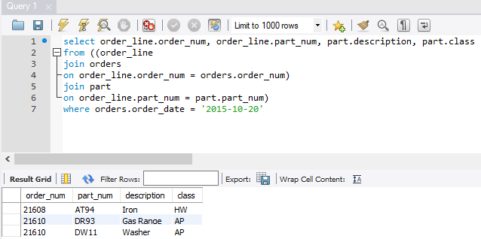

2 ways to solve?

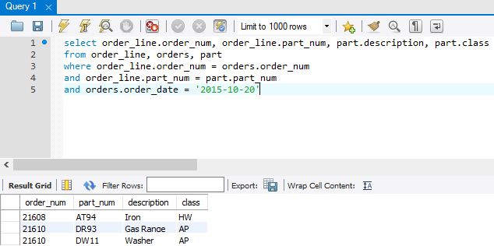

1. For each part, list the part number, description, units on hand, order number, and number of units ordered. All parts should be included in the result set. For those parts that are currently not on order, the order number and number of units ordered should be left blank. Insert your query and results here.

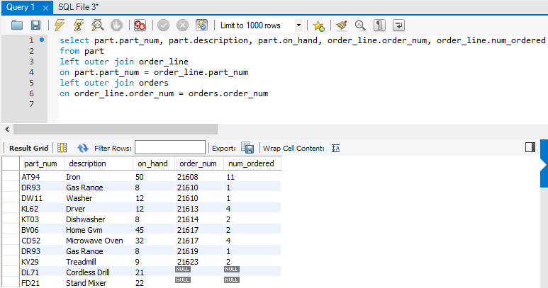

Using the Henry Books database:

1. Using a union, select the publisher information for those publishers that live in Boston or Kingston. Insert your query and results here.

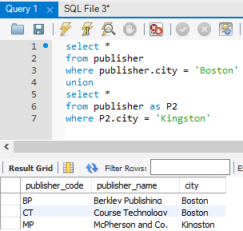

1. Using a subquery, at what branch(es) can the book “A Guide to SQL” be found? List the branch name, branch location, and the number of copies available. Do not explicitly test for book code 669X. Let MySQL do the work for you. Insert your query and results here:

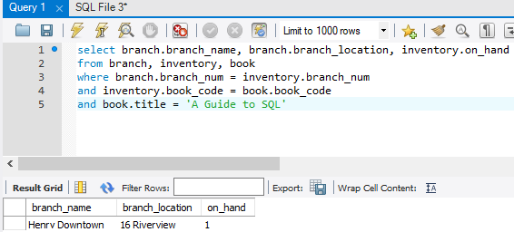

1. Display the name and city of the publisher of the book titled ‘The Edge’. Again, let MySQL do the work for you. Do not explicitly test for book codes or publisher codes. Use the title you have been given. Insert your query and results here.

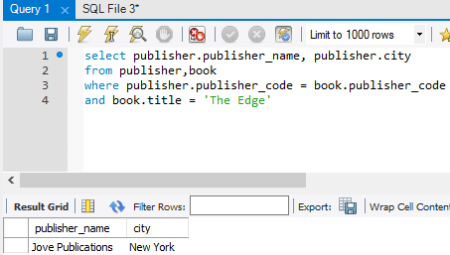

1. List the title of each book published by Penguin USA. Insert your query and results here.

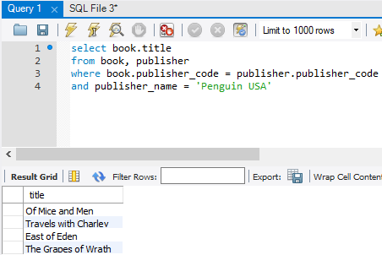

1. List the title, price, and on hand quantities of any book that has a price greater than $25.00. Insert your query and results here.

